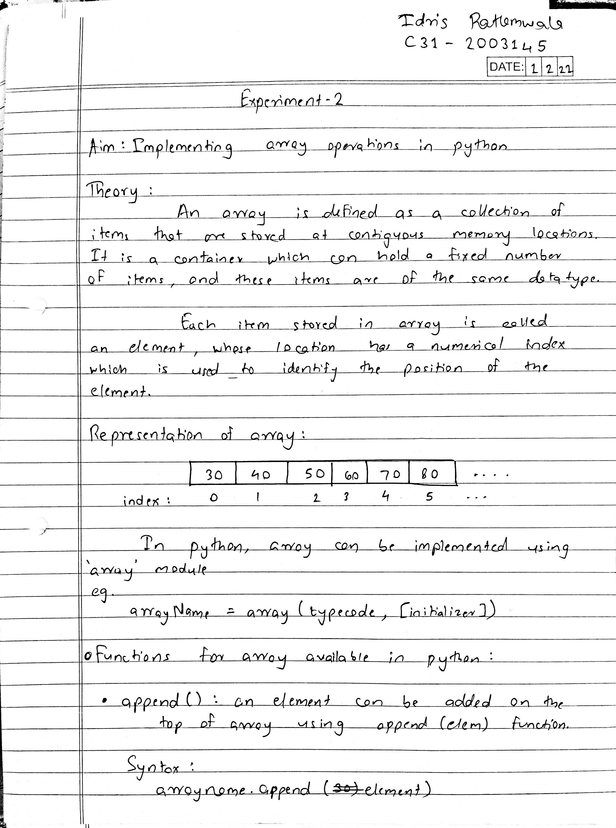 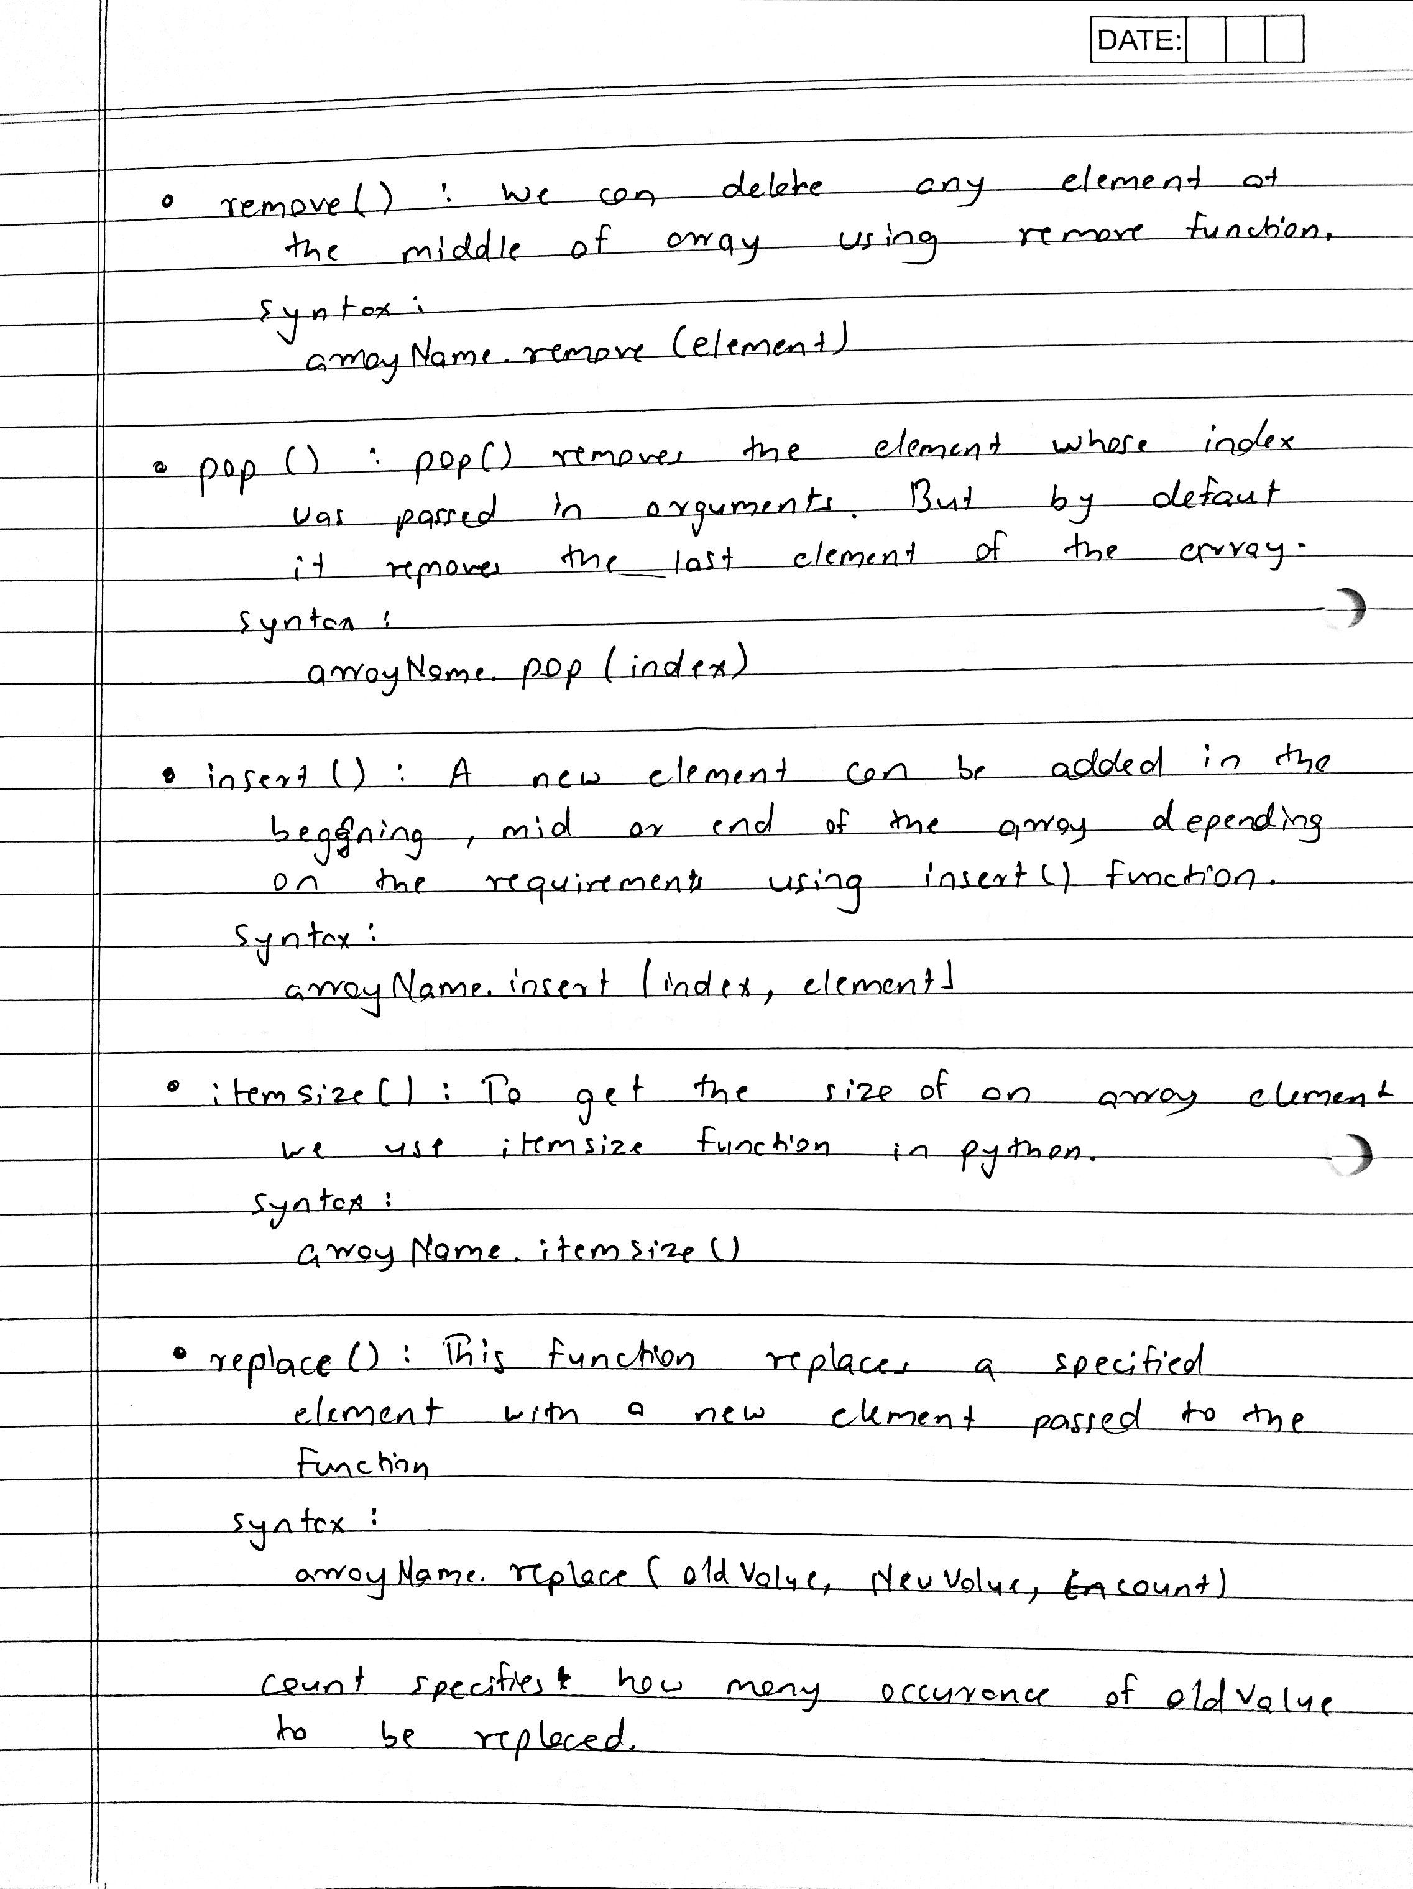 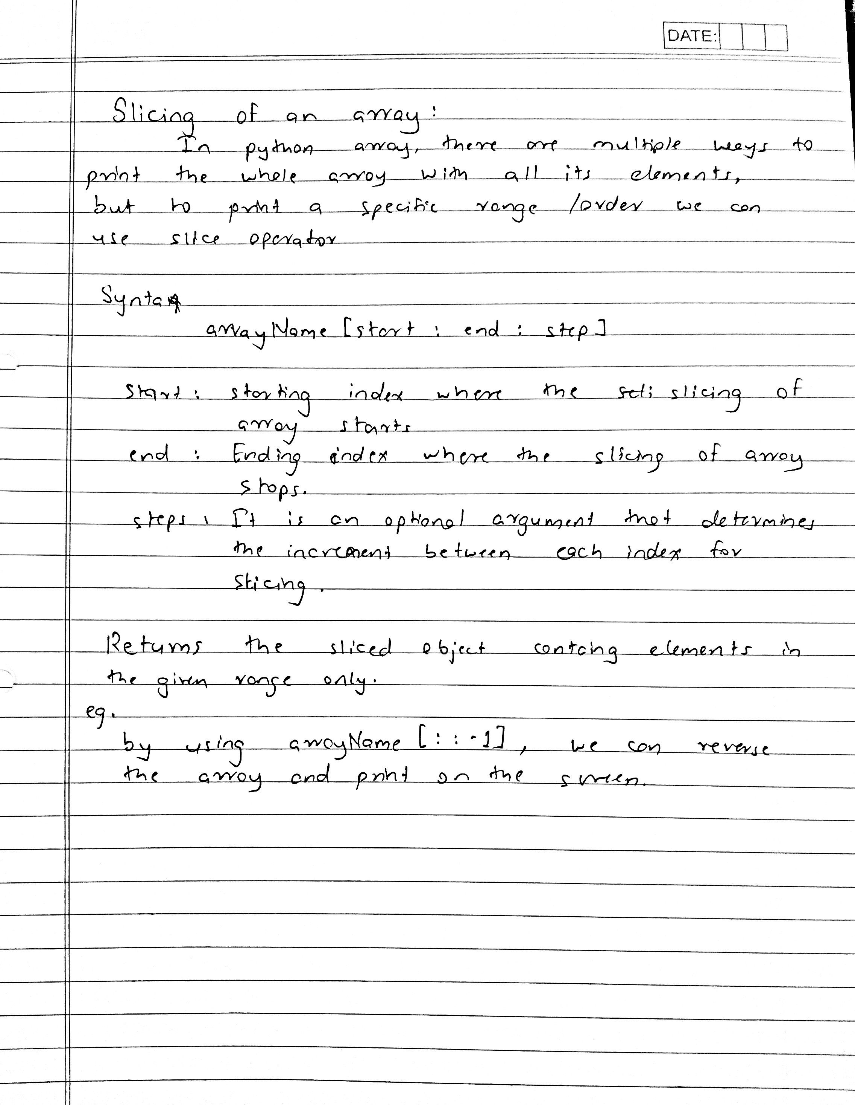

**Programs :**

**1.** Python program to

● Read an array and display

● Append a new item to the end of the array.

● To reverse the order of the items in the array (slice operator)

● Get the length in bytes of one array item

● To append items from another array

● Remove a specified item using the index from an array

● Insert a specified item at the specified position in the array

Program :

import array

arr = array.array('i')

x = int(input("Enter the length of array: "))

for i in range(0, x):

    num = int(input("Enter element %d: "%i))

    arr.append(num)

print("\nInitial array :")

for i in range (0, len(arr)):

    print (arr[i], end =" ")

print()

arr.append(90)

print("\nAfter appending 90 :")

for i in range (0, len(arr)):

    print (arr[i], end =" ")

print()

print("\nAfter reversing :")

rev=arr[::-1]

for i in range (0, len(arr)):

    print (rev[i], end =" ")

print()

print("\nItem size :"+ str(arr.itemsize))

print("\nAfter removing element with index 1 :")

arr.pop(1)

for i in range (0, len(arr)):

    print (arr[i], end =" ")

print()

print("\nAfter inserting 69 at index 3 :")

arr.insert(3, 69)

for i in range (0, len(arr)):

    print (arr[i], end =" ")

print()

Output :

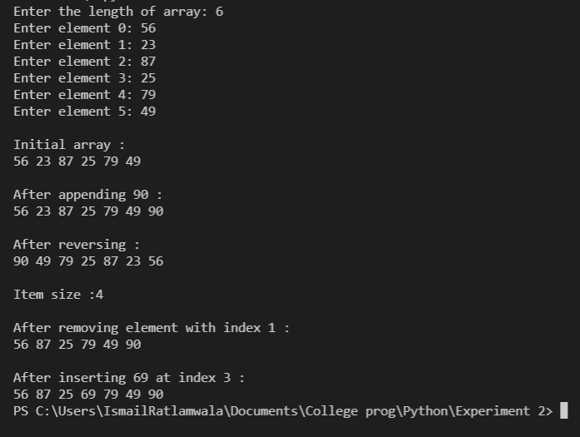

**2.** Python program to remove prime numbers from an array.

Sample input arr[] = {3,4,6,9,13,14,16,17}

Output arr[] = {4,6,9,13,16}

Program :

import array

arr = array.array('i',[3,4,6,9,13,14,16,17])

out = array.array('i',[])

print("\nInitial array :")

for i in range (0, len(arr)):

    print (arr[i], end =" ")

print()

print("Filtered array :")

for i in range(len(arr)) :

    composite = False

    for j in range(2,arr[i]):

        if(arr[i]%j==0) :

            composite =True

            break

    if(composite) :

         out.append(arr[i])

for i in range (0, len(out)):

    print (out[i], end =" ")

print()

Output :

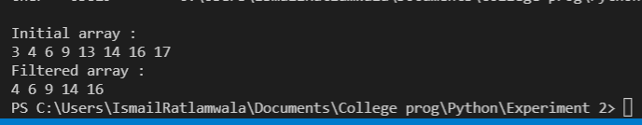

**3.** Python program to change all occurrences of a first character of a

string to @ except for first occurrence.

Sample String : 'apple a day'

Expected Result : 'apple @ d@y'

Program :

string = str(input("Enter a string : "))

result = string.replace(string[0], '@')

print(string[0]+string[1:])

Output :

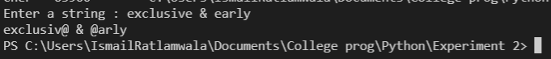

**4.** Python Program

● to sort group of strings into alphabetical order

● to check whether entered string is palindrome or not

Program :

n =int(input("Enter the number of strings : "))

a = []

for i in range(n) :

    a.append(str(input()))

a.sort()

print("\nSorted string :")

for i in range (0, len(a)):

    print (a[i], end =" ")

print("\n")

string= str(input("Enter the string to be checked : "))

if(string==string[::-1]):

    print(string+" is a Palindrome")

else :

    print(string+" is not a Palindrome")

Output :

